|  |  |
| --- | --- |
|  |  |

|  |  |  |
| --- | --- | --- |
| **Lead Author** | **Reviewer** | **Approved for Release** |
| **Name:** Mads Bentzen Billesø | **Name:** | **Name:** |
| **Job Title:** WP6 Contributor | **Job Title:** | **Job Title:** |
| **Partner:** DMA | **Partner:** | **Partner:** |
| **Signature:** | **Signature:** | **Signature:** |

***ACCSEAS WP6 Working Group:***

***MSI-NM User Manual***

Issue: 1.0

Issue Status: Draft

Issue Date: 7/10/2014

# Introduction

MSI-NM is a website and editor that has been developed as part of the ACCSEAS WP6 MSI-NM (T&P) project.

Some of its main features are:

* It provides an editor and viewer for MSI and NM P&T messages.
* MSI and NM P&T messages are accessible in the combined MSI-NM S-100 model, whose specification is also part of the ACCSEAS WP6 MSI-NM (T&P) project.
* MSI-NM integrates with the Maritime Cloud and EPD (e-Navigation Prototype Display) systems. Indeed, it defines REST and Maritime cloud API’s for easy integration with all other systems, subject to the usual user authorization restrictions.
* MSI-NM is Open Source and highly customizable, making it easy to develop implementations for other countries. This manual will focus on the Danish implementation.

Limitations:

* MSI-NM is a prototype system, and should not be used for operational purposes in its current incarnation.
* Specifically, some features have been included for demonstration and proof-of-concept purposes only, such as single-sign on with external systems (Google supported for now). Similarly, only parts of the front pages has been translated into other languages to demonstrate internationalization. The rest of the site is only available in English for now.

# System Requirements

## Browsers

Being a prototype system, backwards compatibility with old browser version has *not* been a priority. Please use the latest browser version of you chosen type, i.e.

* Chrome: Use version 37 or newer – although MSI-NM is known to work well with older Chrome versions.
* Internet Explorer: User version 11 or newer. MSI-NM is known not to work properly with older versions of Internet Explorer.
* Safari: Use version 7 or newer.
* Mobile devices: In general, MSI-NM has been optimized to work well with mobile devices such as iPhones and iPad. However, it has not been thoroughly tested on the plethora of devices and their different browser versions.

## JavaScript

JavaScript must be enabled in the used browser. See if you have JavaScript enabled and how to enable it at this internet site: <http://enable-javascript.com/>

## Cookies

Cookies should be allowed as a cookie is used to store the currently chosen language. Similarly HTML5 local storage is used to store a “token” for authenticated users.

## Internet Usage

MSI-NM requires Internet access, and will not run properly in offline mode.

# Functionality

## Users and Roles

MSI-NM’s main purpose is to serve as an MSI-NM editor. However it can also be used by end users to view and search MSI and NM messages.

To accommodate these needs, each registered user is assigned a set of hierarchical roles.

* Unauthenticated users: Users of the MSI-NM website that have not logged in, do not have an assigned role. They can still view and search the list of active and historical MSI and NM messages.
* User: All registered and logged in users have a “user” role on the MSI-NM website. This allows them to bookmark specific MSI-NM messages, create and subscribe to MSI-NM mailing lists, and to report observations relevant to the maritime authorities.
* Editor: An “editor” role allows the user (employee, that is) to create, edit, publish and cancel MSI-NM messages.
* Admin: If the user furthermore has the “admin” role, she can manage users, mailing lists, and all the base data (areas, categories, charts, etc.) used for creating MSI-NM messages.
* Sysadmin: The “sysadmin” role should only be assigned to the technical administrator of the MSI-NM website. The system administrator can manage underlying system settings and e.g. configure legacy integration.

## Front Page

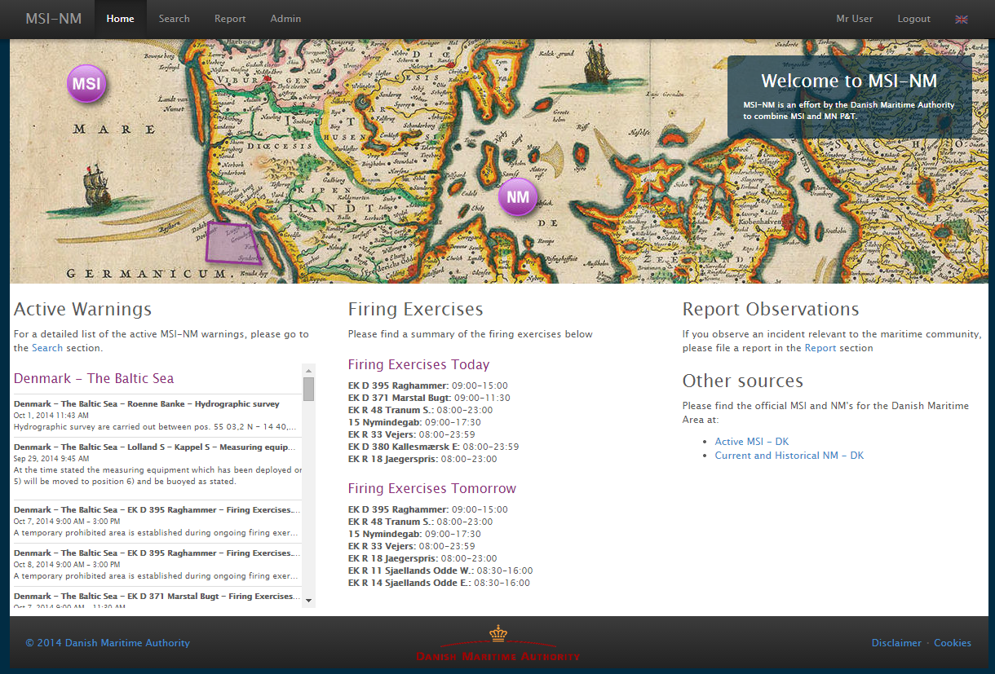 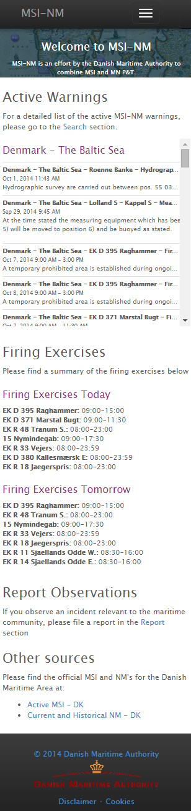

*Front page as viewed on a desktop PC and on a mobile device*

The front page, or home screen, is the main entry point to the MSI-NM system. As exemplified above, its appearance may differ substantially depending on whether you access it from a desktop PC or a mobile device. Desktop screenshots will be used for the remainder of this user manual.

The top menu is shared among all pages and will be described in the next section.

The rest of the front page is divided into three main sections:

* Active warnings: The list of currently active MSI and NM messages grouped and ordered by their associated area.
* Firing Exercises: An alternative presentation of the subset of active MSI messages that represents firing exercises (technically: MSI’s that are assigned a “Firing Exercises” category) and are due today and tomorrow.
* Misc.: The last column contains miscellaneous information, such as a shortcut to the page where an end-user can report an observation, and links to the official sites for MSI and NM messages.

## Top Menu







*Top menu for an anonymous user, a logged in user and an administrator*

The Top Menu is present at all pages. The “Search”, “Report” and (for administrators) “Admin” links navigates the user to the other main pages of the MSI-NM system. These pages are detailed in separate sections of this user manual.

When a user access the MSI-NM website anonymously, they will see the “Login”, “Register” and language options in the Top Menu:

Login

The login screen allows registered users to log in using their e-mail address and password.

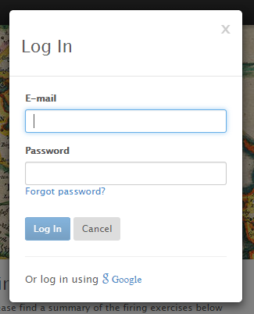

As depicted above, the MSI-NM system can be configured to allow federated authentication via e.g. Google. This allows users to log in using their existing Google account, thus avoiding the registration process.

Currently, the feature is only enabled in the Danish MSI-NM system, as it requires the MSI-NM website to be configured as a Google Application.

The federated authentication feature will be expanded in the future to allow users to log in using their Facebook, Twitter or Maritime Cloud accounts.

Registration

New users can register by clicking the Register link:

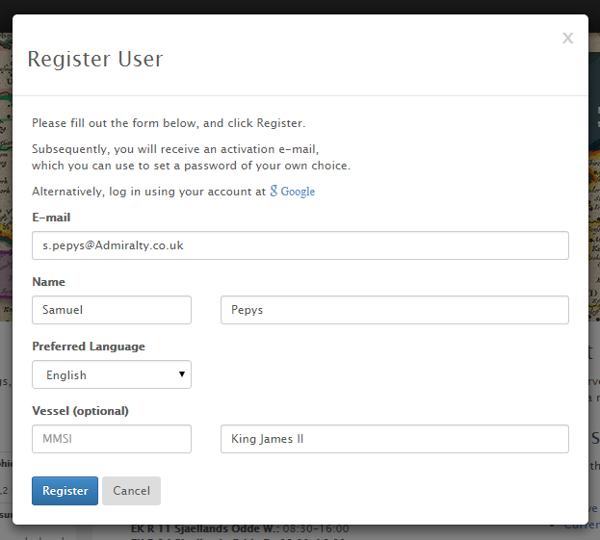

The e-mail address is used as the main identifier for the user, and thus, can only be used for registration once. The selected preferred language is used for e-mail correspondence.

When “Register” is clicked, a verification e-mail will be sent to the user. The e-mail contains an activation link which, when opened, will allow the user to confirm registration and set a password.

After successful registration, the user can log in, and will have access to features such as bookmarking of messages and mailing lists.

Language Selector

The language selector allows the user to set the website language. The available set of languages is a system configuration:

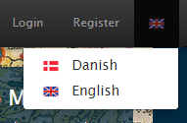

The selected language applies to two types of content: the static website texts and the dynamic MSI-NM data.

At the time of writing, only a small subset of the static website texts have been translated.

As for the MSI-NM data, it is up to the editors to ensure that messages are translated. If a translation is missing, this will be indicated with a small flag, as depicted below where an English translation of an NM message is unavailable:

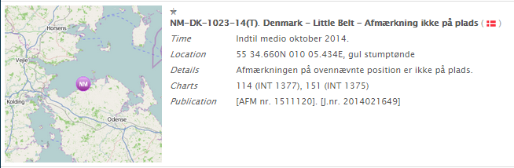

User Menu

When a user is logged in, the “Login” and “Register” links of the Top Menu are replaced with a user menu and a Logout link.

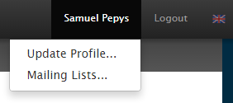

The “Update Profile…” option allows the user to update personal data such as name and preferred language. It is very similar to the Registration dialog detailed in a previous section.

The “Mailing Lists…” link allows the user to manage her mailing list subscriptions:

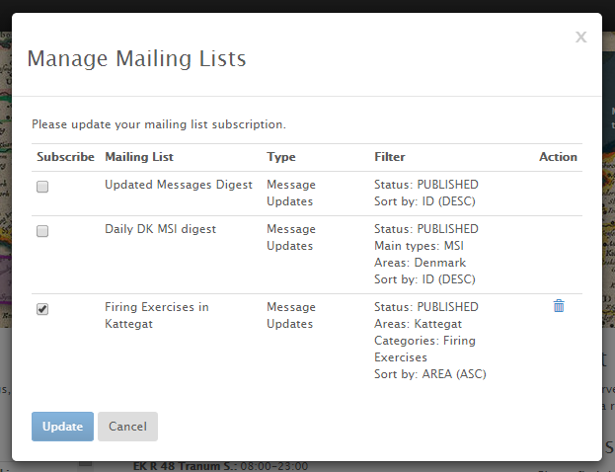

The list of mailing lists available to the user is the combined set of *public* mailing lists created by administrators and the mailing lists that the user has created herself. The creation of mailing lists is detailed in a subsequent section.

## Message Details Dialog

Whenever the user clicks an MSI or NM message, for instance on the front page list of active messages, the *Message Details dialog* opens and displays detailed information about the selected message:

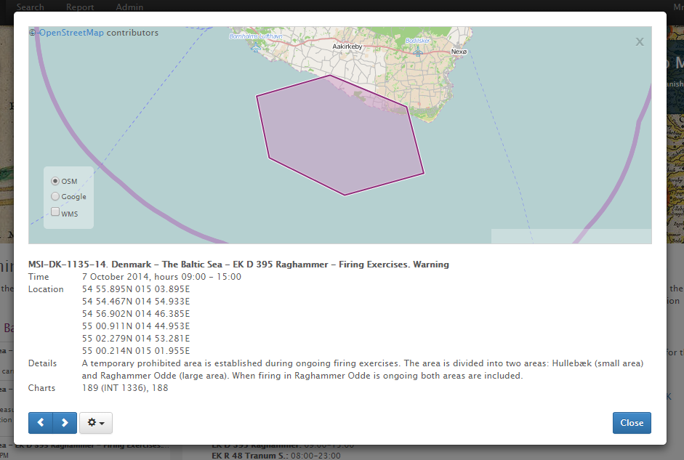

*Message Details Dialog*

The dialog lists all the relevant details of the selected message, such as ID, area, title, time, location, description, charts, attachments, etc.

Message Details Map

The top half of the dialog contains a map with an outline of the message locations. You can navigate the map with the mouse (or fingers on mobile devices), zoom in and out, etc. Depending on the configuration of the MSI-NM system, you may be able to display alternative map layers, such as WMS or Google Maps:

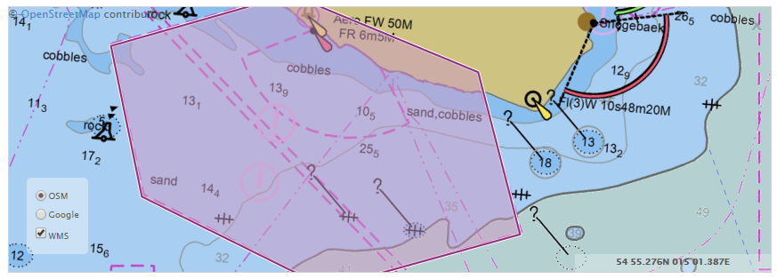

Navigation Buttons

The navigation buttons in the bottom left corner of the Message Details Dialog allows you to iterate to the previous or next message of the current message list without closing the dialog.

MSI-NM messages may contain “references” to other messages (an update, a cancellation, a repetition, etc.). These references will be hyperlinks that you can click to display the referenced message. In that case, the previous-next navigation buttons changes into a “Back” button, so that you can navigate back to the original message.

Action Menu

The Message Details Dialog Action Menu sits next to the Navigation Buttons:

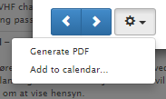 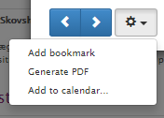 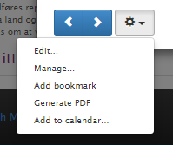

*Action Menu – for an anonymous user, a logged in user and an editor*

As can be seen above, the available options differ depending on whether you are anonymous, logged in, or an editor (or administrator). “*Editing”* and “*Managing”* messages will be detailed in subsequent sections.

* Add/Remove bookmark: Logged in users can bookmark individual messages, and subsequently search for bookmarked messages on the Search page.  
  An editor can e.g. utilize this feature to bookmark a set of *standard* *messages* that can be copied when creating new messages.
* Generate PDF: Will create a PDF document with the selected message. This is particularly useful if you wish to make a printed copy of the selected message.
* Add to calendar: Will generate an ICS file in the iCalendar format for the selected message. The ICS file can subsequently be added to most popular calendar applications.  
  NB: This feature is currently at a proof-of-concept level and not very robust.

## Search Page

The Search Page is the main page for displaying MSI-NM messages. Upon first entering the Search Page, the list of messages being displayed is the currently active (published) MSI and NM messages.

View Modes

The View Mode sub-menu of the Top Menu allows you to select between four different view modes:

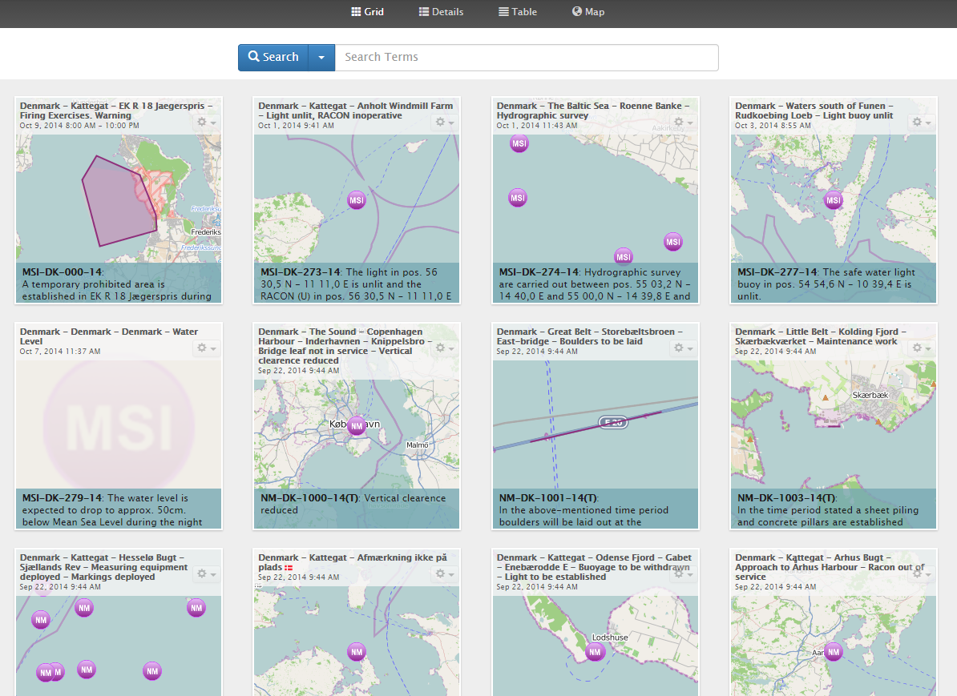

*Grid View Mode*

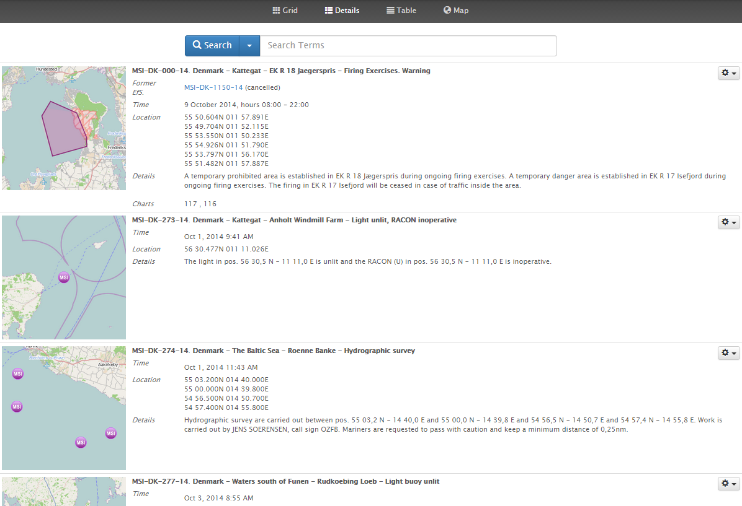

*Details View Mode*

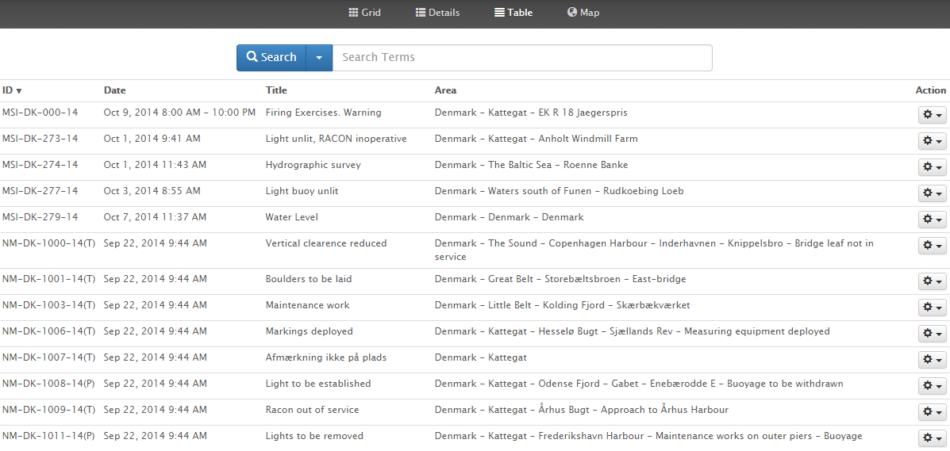

*Table View Mode*

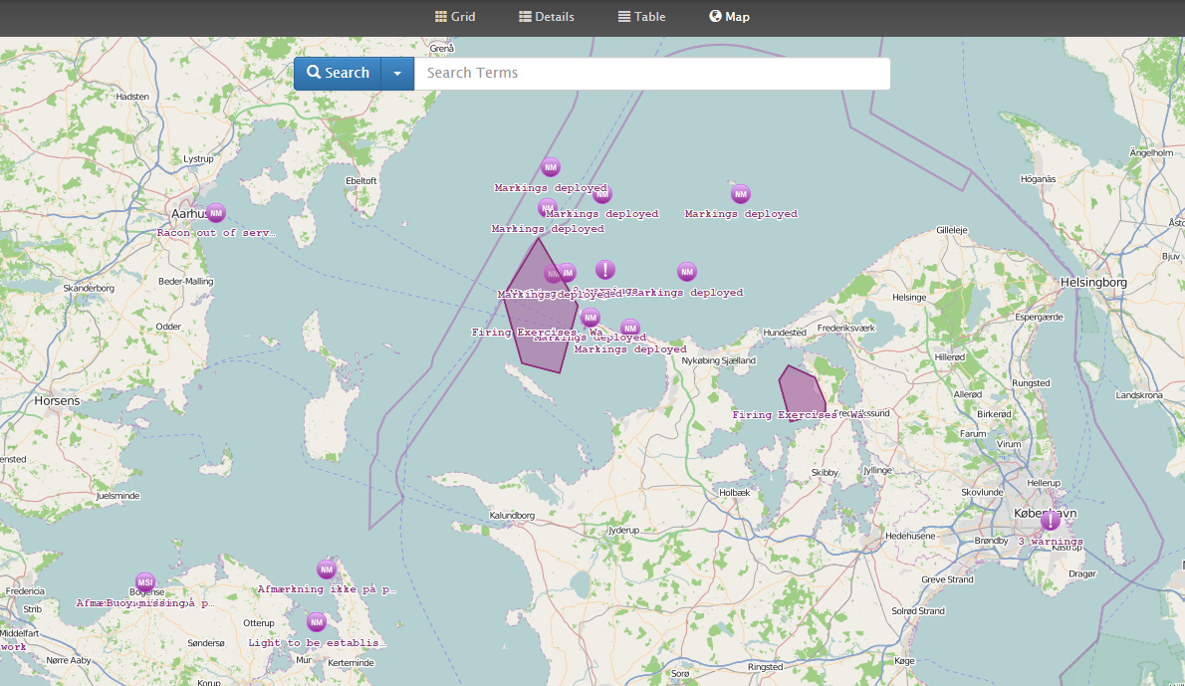

*Map View Mode*

In all the view modes, clicking on a message will open the *Message Details Dialog* described in a previous section.

For all view modes, bar the Map view mode, you get direct access to the action menu associated with the message details, also described in the previous section:

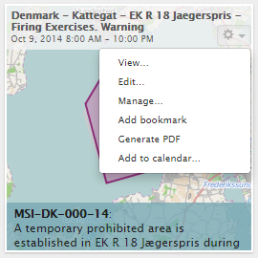

*Action Menu – for editors*

Map View Mode Specifics

The Map view mode use *clustering* to avoid clutter when you zoom out. So, adjacent MSI-NM messages may be clustered into a single icon on the map with a title that indicates how many message are being combined:

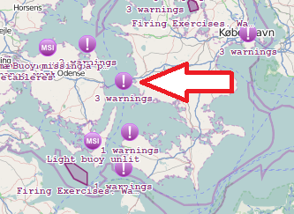 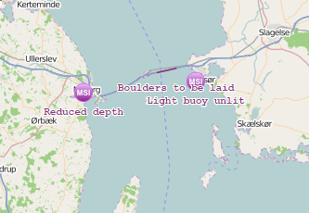

*Map Clustering – before and after zooming in at arrow*

Symbols used on in the Map view mode:

|  |  |
| --- | --- |
| Symbol | Meaning |
|  | MSI and NM messages that define locations in term of polygons, circles or polylines are drawn with their actual outline. |
|  | MSI messages that define their locations in term of point positions are depicted using an “MSI” symbol. |
|  | NM messages that define their locations in term of point positions are depicted using an “NM” symbol. |
|  | Clustered messages are combined into a single “!” symbol positioned at the center of the involved messages. |

As with the map in the Details Dialog, you can navigate the search result map with the mouse (or fingers on mobile devices), zoom in and out, etc. Depending on the configuration of the MSI-NM system, you may be able to display alternative map layers, such as WMS or Google Maps.

Searching

The Search Page provides a plethora of different functions stashed away in the Search Menu:

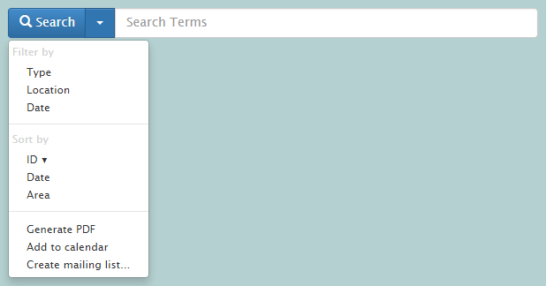

The functions are largely grouped into *filtering options, sorting* and *miscellaneous* functions, all of which will be detailed below.

In general, when the filtering criteria have been changed, click the “Search” button to update the message search result.

Search Field

The main search text field allows you to filter the MSI-NM messages using Google-like search terms. The searched message data include most of the fields associated with a message, such as ID, type, description, title, area, categories, charts, etc. For data that exists in translated version, the currently selected website language is used.

Examples:

|  |  |
| --- | --- |
| Search Term | Search Result |
| bornholm survey 1301 | Messages matching any of the search terms, for example where the area matches “Bornholm”, or the title contains the word “survey”, or the message is associated the sea chart “1301”. |
| “bornholm w” | Messages that have an exact match for the term “bornholm w”. |
| +bornholm -survey | Only messages that matches the term “bornholm” but not the term “survey”. |
| born* | All messages that matches a term starting with “born”. |

Filtering by Type

If you select the Filter by Type option from the Search Menu, you get additional message type-related search options:

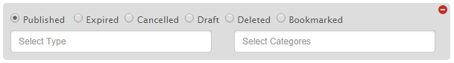

The topmost list of options lets you select the message status, one of:

* Published: This is the default option, and covers messages that are currently published, i.e. active.
* Expired: Published messages with a well-defined valid-to date, will automatically be expired by the system when the valid-to date has passed. These messages will be assigned the “Expired” status.
* Cancelled: Alternatively, if the editor manually cancels a published message, it is assigned a “Cancelled” status.
* Draft: This search option is only available to editors. Draft messages are messages that have not yet been published.
* Deleted: This search option is only available to editors. Draft message can be deleted.
* Bookmarked: This search option is available to all logged in users, and allows them to filter on bookmarked messages, irrespective of the status of the messages.

The “Select Type” field can be used to filter by the message types, i.e. “MSI” or “NM”, or any of the sub-types “Permanent NM”, “Temporary NM”, “Preliminary NM”, “Miscellaneous NM”, “Local Warning”, “Coastal Warning”, “Subarea Warning” or “Navarea Warning”. The field allows for selection of multiple types, and provides auto-completion to help you fill out valid options.

The “Select Categories” field can be used to filter by message categories, such as “Firing Exercises”. The available categories are defined by administrators on the Categories Admin Page, detailed in a later section. The field allows for selection of multiple categories, and provides auto-completion to help you fill out valid options.

Categories are hierarchical, so, filtering on a category will automatically include message associated with all sub-categories.

Filtering by Location

If you select the Filter by Location option from the Search Menu, you get additional message location-related search options:



The “Select Charts” field can be used to filter by message sea charts, such as “101 (INT 1301)”. The available charts are defined by administrators on the Charts Admin Page, detailed in a later section. The field allows for selection of multiple charts, and provides auto-completion to help you fill out valid options.

The “Select Areas” field can be used to filter by message areas, such as “Kattegat”. The available areas are defined by administrators on the Areas Admin Page, detailed in a later section. The field allows for selection of multiple areas, and provides auto-completion to help you fill out valid options.

Areas are hierarchical, so, filtering on an area will automatically include message associated with all sub-areas.

Alternatively, by clicking the “Locations” button you can outline the specific geographical locations to filter by. This opens the *Location Editor,* used at various places throughout the MSI-NM system. Remove the location filter again by clicking the trash button.

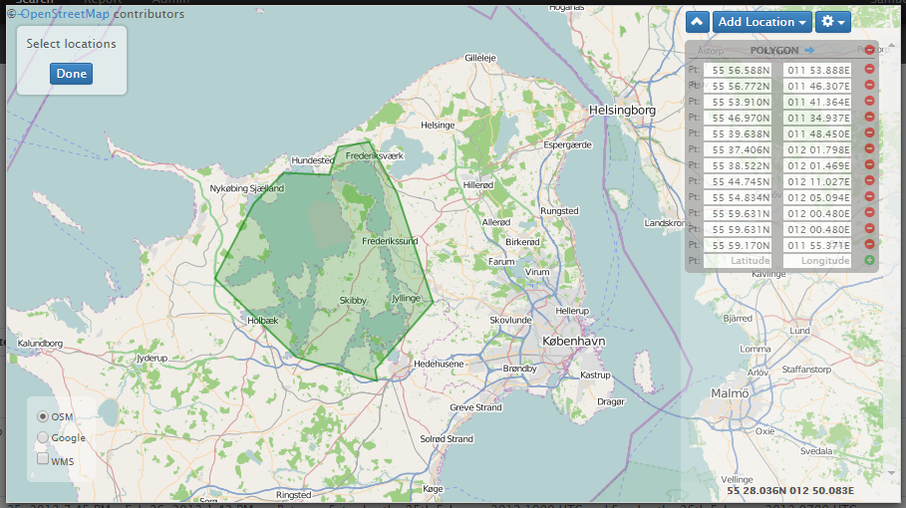

*Filtering messages by a specific location.*

A subsequent section will detail the functionality of the Location Editor.

Filtering by Date

If you select the Filter by Date option from the Search Menu, you get additional message date-related search options:



Specify the from-date and/or the to-date to filter messages on their creation dates.

Sorting

The message search result can be sorted by the message identifier (“ID”), by the message valid-from date, or by the message area. After selecting the sort key from the Search Menu, click the Search button to apply the changes.

Toggle the sort order (ascending or descending) by re-selecting the same sort key in the Search Menu.

Area Sorting Specifics

The area ordering is defined by administrators on the Areas Admin Page. When search results are sorted by area, the area names will be inserted as group titles:

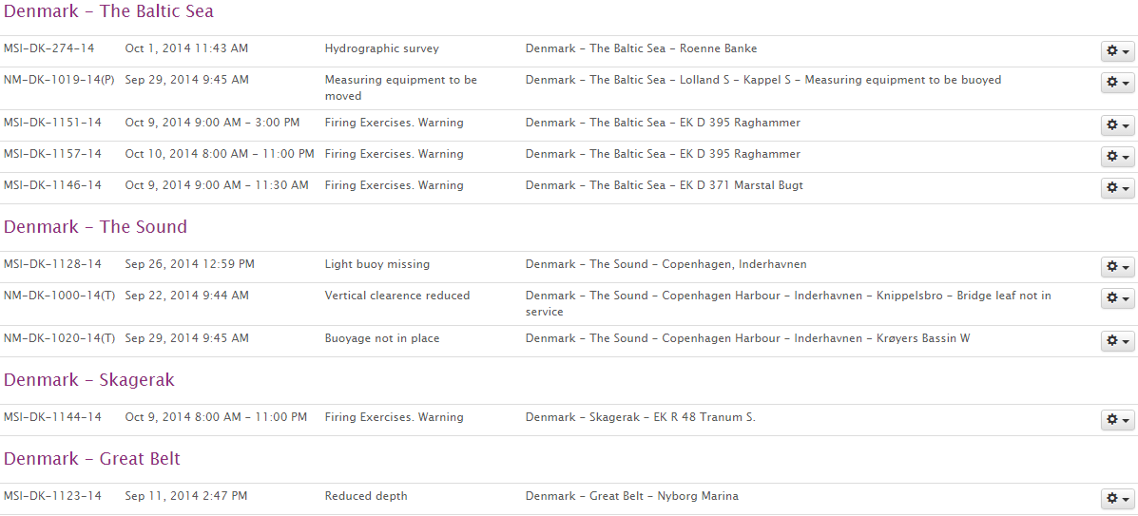

Generate PDF

The “Generate PDF” Search Menu option will export the current message search result as a PDF file. The PDF will contain a detailed description of each message.

If messages are sorted by area, the area titles will be inserted in the PDF as well. Example:

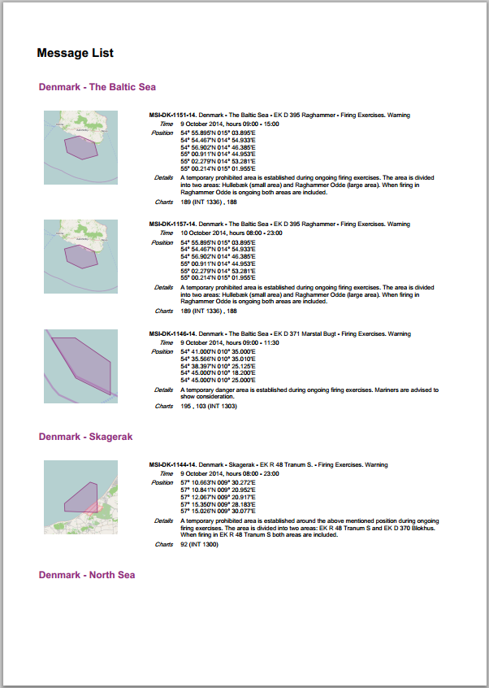

Add to Calendar

Choosing “Add to Calendar…” from the Search Menu will present you with a URL for subscribing to the active messages in an iCalendar format. Most calendar programs can subscribe to external URL’s in this format.

NB: This feature is currently at a proof-of-concept level and not very robust.

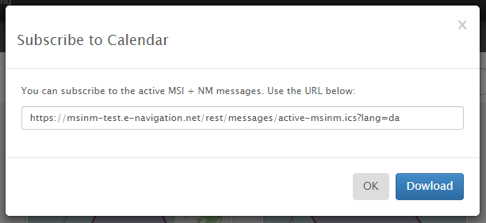

Create Mailing List

By selecting “Create Mailing List…” from the Search Menu, any logged in users can create a new mailing list based on the current search filter. Example:

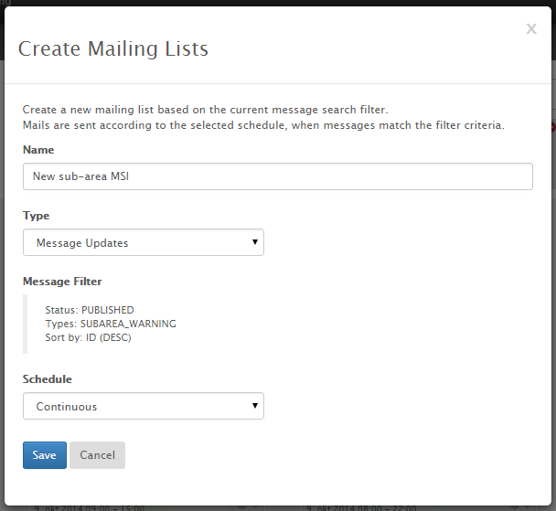

*Create Mailing Lists – for non-administrators*

The mailing list options available to non-administrators are:

* Name: The name of the mailing list
* Type: Either “Message Updates” or “Message update”. The former type will collate all messages matching the filter criteria in a single mail. The latter type will result in one e-mail per message matching the filter criteria.
* Message Filter: The message filter defines which messages are included in the mailing list. It is a textual description of the current message search filter when the mailing list is created.
* Schedule: Mailing list e-mails are sent according to the selected schedule. Available options:
  + Continuous: E-mails are sent whenever a new message matches the mailing list filter.
  + Daily: E-mails are sent daily for messages matching the mailing list filter, at the specified hour of day.
  + Weekly: E-mails are sent weekly for messages matching the mailing list filter, at the specified day.

As described in a previous section, the user can subsequently manage subscription to existing mailing lists by choosing the “Mailing List…” option of the User Menu.

A sample mailing list e-mail can be seen below:

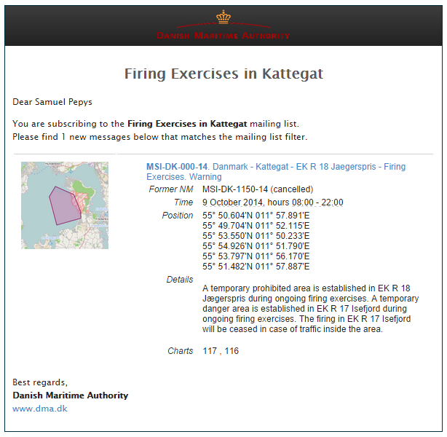

Create Mailing List - Administrators

When administrators create mailing lists, they get more options, as seen below:

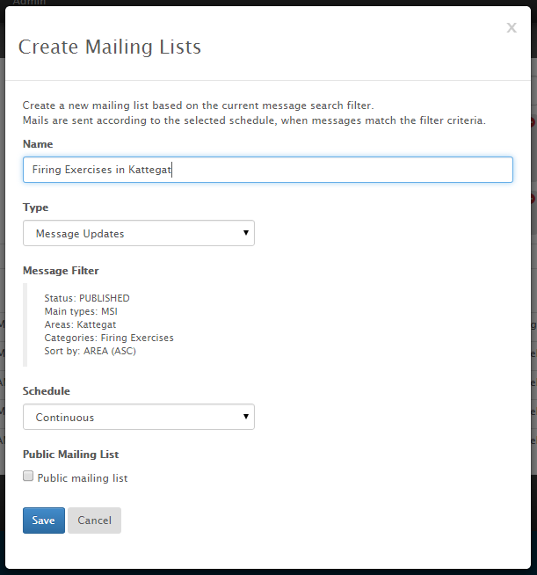 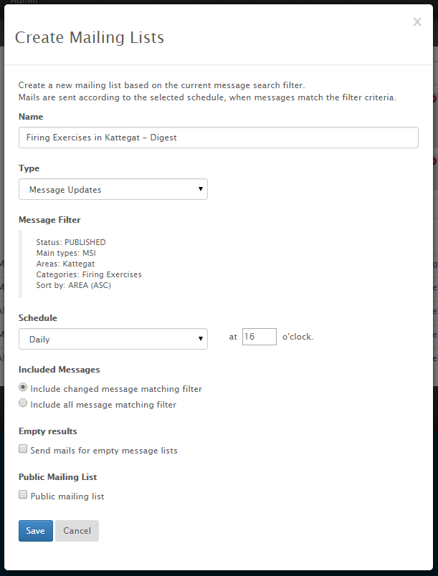

*Create Mailing Lists – for administrators*

The extra options are:

* Type: In addition to the collated “Message updates” and non-collated “Message Update” mailing list types that all users can choose from, the administrator can choose a “Navtex” type that formats messages as NAVTEX messages. Additional types may be added later on.
* Public Mailing List: If the administrator marks a mailing list as public, all other users will be able to subscribe to the mailing list.
* Included Messages: By default, only changed messages (i.e. newly published message) are included in the mailing list filter. However, if a daily or weekly schedule has been selected, the administrator can choose that all messages matching the filter should be included, not just changed messages. This option can be used to e.g. create daily digests.
* Empty results: If a collated message type (e.g. “Message Updates”) has been selected along with a daily or weekly schedule, this option can be used to select whether mails should be sent for empty message search results or not.

Administrators can manage mailing list subscribers for all mailing lists on the Mailing Lists Admin Page detailed in a subsequent section.

Sample NAVTEX e-mail sent to subscribers of the “Navtex for Baltico” mailing list:

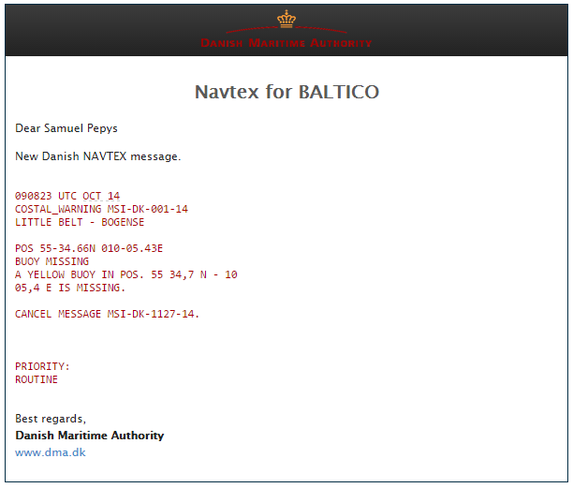

## Location Editor

The ubiquitous Location Editor is used at various places in the MSI-NM system, e.g. on the Search Page, in the Message Editor and on the Areas Admin Page:

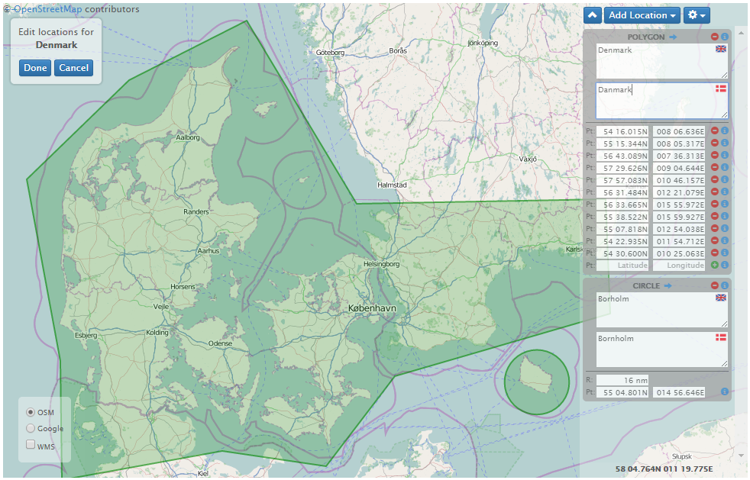

The editor allows you to specify a list of locations using a geographical editor. Use the “Add Location” button to insert a new locations of the selected type:

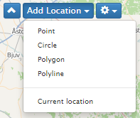

Once a location type has been selected, the actual location can be marked up on the map in the following way:

|  |  |
| --- | --- |
| Location Type | Explanation |
| Point | Click the mouse at the desired location on the map. You can adjust the lat-lon coordinates in the right-hand panel or drag the point to a new position. |
| Circle | Click the mouse at the desired circle center on the map and drag the extent of the circle. You can adjust the center lat-lon coordinates and the radius in the right-hand panel or drag the center point to a new position. |
| Polygon | Click the mouse at the desired location on the map to start adding the polygon outline. Click again to add consecutive vertices of the polygon, and double-click to complete the polygon. You can adjust the lat-lon coordinates in the right-hand panel or drag the vertices to a new position. Once the polygon is selected, you can also insert new vertices by dragging the mid-line points. |
| Polyline | Polylines are added similarly to the polygons, except that the last vertex will not be connected to the first in a closed shape. |
| Current location | Will add a circle at the current location if the web browser is location aware. |

In addition to using the mouse to edit locations directly on the map, you can also edit the locations manually in the right-hand panels. Example:

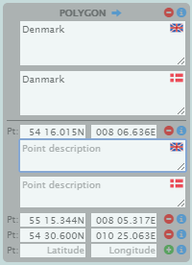

The title line of the location panel states the type of the location, e.g. “POLYGON”. Clicking the blue arrow () next to the title will zoom the map to the extent of the location.

Clicking the red minus-button () next to the title will delete the entire location, whereas clicking the minus-button next to a position will delete that specific point. Clicking the green plus-button () next to the last position will add this point to the location.

Clicking the blue info-button () in the title line will toggle the visibility of the localizable description fields for the location. Clicking the info-buttons next to individual positions will toggle the visibility of the description fields for that specific position.

The location editor also sports an action menu:

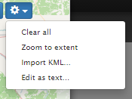

* Clear all: Removes all locations.
* Zoom to extent: Zooms the map to the combined extent of all locations in the editor.
* Import KML….: Lets you import the locations of a Google Maps KML or KMZ files.
* Edit as text…: Lets you edit the locations in a plain text editor. This is an expert function, as you need to know the details of the plain-text format.

## Message Editor

The Message Editor is used for creating new MSI and NM messages, and for editing existing messages.

A new draft message is created using the “Edit” link on the Search Page, which is only visible for editors and administrators:

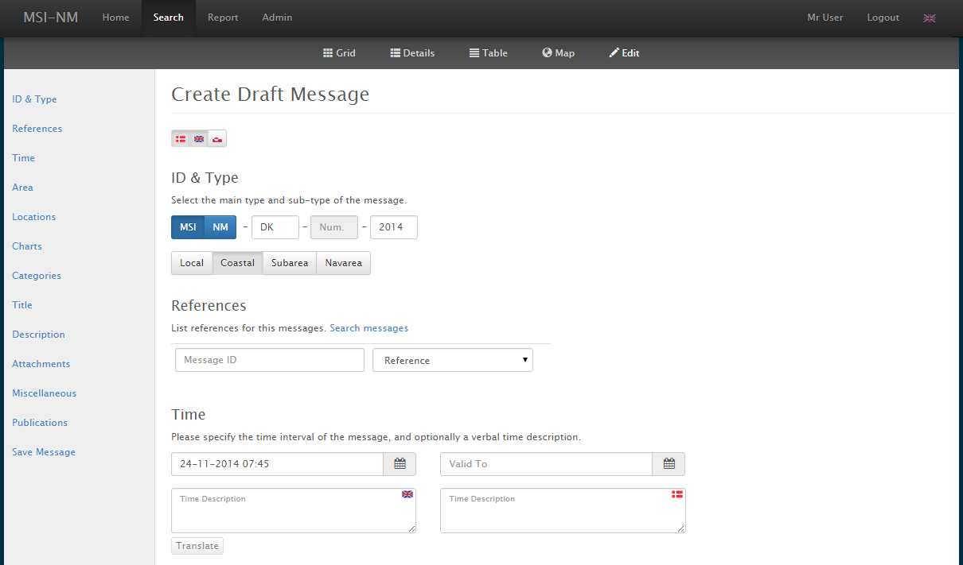

Existing messages are edited by choosing the “Edit…” option of the message details menu, only visible for editors and administrators.

Please note, however, that once a message has been published, it cannot be edited anymore (except by system administrators). Please refer to the Message Management section for details about the message life cycle.

The remainder of this section will detail the message editor fields group by group.

Message Languages

The MSI-NM system can be configured to support any number of message languages. Typically, only two languages are used: The local language and English. In our example Danish and English are supported, and Greenland is available as an optional language. Selecting the Greenland flag will add an additional field for all localizable message fields. Example:

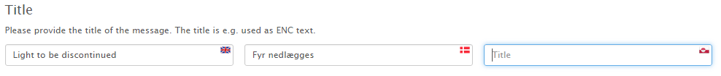

ID & Type

The ID & Type fields are used to specify the type, sub-type and unique identifier of the message.

The main type of a message is either “MSI” or “NM”. Once the main type has been selected, the sub-type can be selected. For MSI the sub-type is either “Local Warning”, “Coastal Warning”, “Subarea Warning” or “Navarea Warning”. For NM, the sub-type is either “Permanent NM”, “Temporary NM”, “Preliminary NM” or “Miscellaneous NM”:

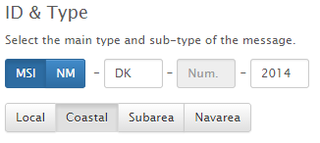 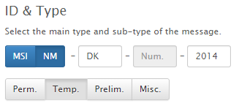

The *series identifier* of a message consist of the following parts:

1. Main type: Either MSI or NM.
2. Authority: The maritime authority or country code, e.g. “DK” for Denmark.
3. Sequence number: This number will automatically be assigned when a message is published. There will be a unique sequence for each combination of main type, authority and year.
4. Year: The year the message was issued.

This series identifier format, which is an extension of the series identifier format usually adopted, makes it easy to uniquely reference messages across a shared NM and MSI domain.

References

Message references are used to define a relationship to another message. A reference consists of a series identifier of the referenced message and a reference type:

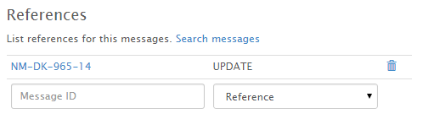

The supported reference types are: “Reference”, “Repetition”, “Cancellation” and “Update”.

Message references are hyperlinked throughout the MSI-NM website, making it easy to navigate a chain of associated messages.

Time

The Time section consists of a mandatory valid-from date field and an optional valid-to date field, plus localizable text fields that may be used for a textual description of the time interval for which the message is valid:

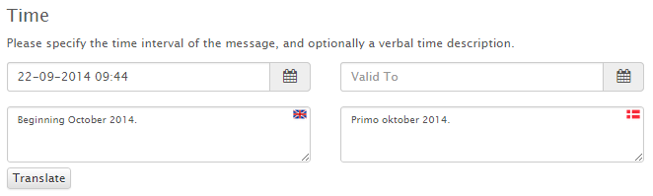

The Time section also sports a “Translate” button that, for certain common textual time descriptions, can translate between English and the local language, and compute the valid-from and valid-to date field as well.

A few examples of the kind of time descriptions that can be translated:

* End May - beginning June 2014.
* Week 22 2014.
* 18 June 2014.
* 14 June 2014, hours 0800 - 15 June 2014, hours 2000.
* Mid-July - Mid-October 2014.
* Until 7 June 2014.
* a) Until 11 October 2014.  
  b) 23 May - 7 June 2014, hours 0500 - 2200.  
   16 June - 31 July 2014, hours 0500 - 2200.
* June 2014  
  10 hours 0900 - 1500.  
  11 - 12 hours 0910 - 1345.

Area

The mandatory Area field is used to specify the main area of the message. The available areas are defined by administrators on the Areas Admin Page, detailed in a later section. The field provides auto-completion to help you fill out a valid area.

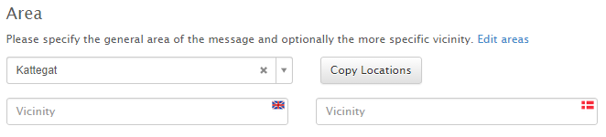

If the geographic locations have been defined for the selected area, then the locations can be copied from the area to the message using the “Copy Locations” button. This is particularly useful for areas, such as firing exercise areas, which have very well-defined locations.

The Area section also contains localizable “Vicinity” fields, for specifying additional area information not defined in the Area database.

Locations

The Message Editor contains an embedded Location Editor for specifying the geographical locations of the message.

Locations and individual position can be associated with localized descriptions. The functionality of the Location Editor has been described in detail in a previous section.

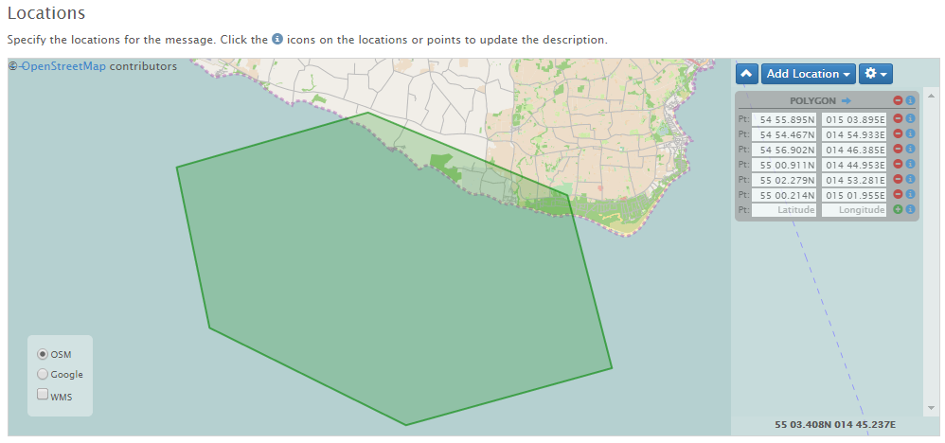

Charts

The “Charts” field can be used to select the sea charts relevant to the message, such as “101 (INT 1301)”. The available charts are defined by administrators on the Charts Admin Page, detailed in a later section. The field allows for selection of multiple charts, and provides auto-completion to help you fill out valid charts.

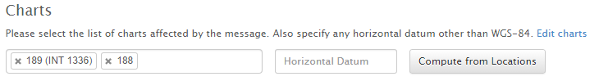

If the charts have been properly defined by the administrator, including scale and geographical extent, then clicking the “Compute from Locations” button will automatically compute the relevant sea charts based on the current message locations, as defined in the Location Editor. The charts will be sorted with the highest resolution chart first.

If a non-standard horizontal datum (i.e. not WGS-84) is used for the message, then this can be specified in the “Horizontal Datum” field.

Categories

The “Categories” field can be used to select the categories relevant to the message, such as “firing exercises”. The available categories are defined by administrators on the Categories Admin Page, detailed in a later section. The field allows for selection of multiple categories, and provides auto-completion to help you fill out valid categories.

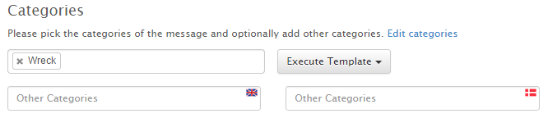

The Categories section also contains localizable “Other Categories” fields, for specifying additional categories not defined in the Category database.

Templates

The MSI-NM Editor includes a template system that allows you to easily fill out new standard messages based on *templates.* The set of available templates is tied to the current message category selection in the Message Editor, and the templates themselves are defined and maintained on the Templates Admin page, detailed in a later section.

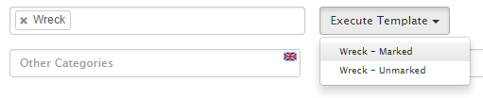

Before executing a template, such as “Wreck – Marked” seen above, you will have selected the message type, the message valid-from and –to dates, the message locations, and the category.

Next, execute one of the templates available from the “Execute Template” drop down menu. Examples:

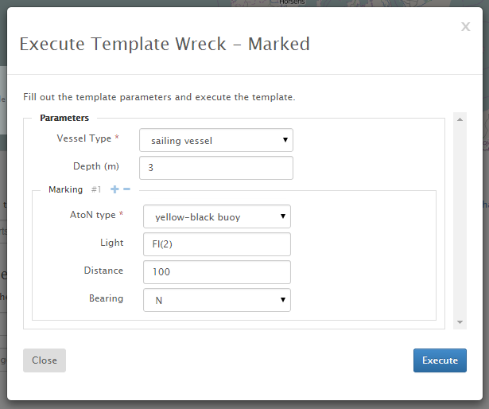

*Executing template for a marked wrecks*

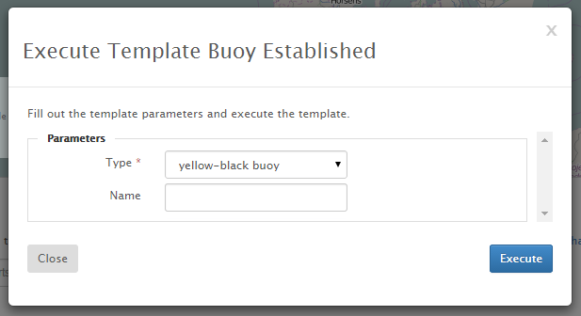

*Executing template for an established buoy*

Depending on the type of template selected, you will be asked to fill out a set of parameters before executing the template. Mandatory parameters are marked with a red asterisk.

When you click the “Execute” button, the template is executed with the specified parameter values and the current message data as input.

The result is that various fields, such as *title, description, NAVTEX message*, etc., gets automatically populated with standardized texts. In the “marked wreck” example above, the fields will be populated as follows (assuming that the NAVTEX and Audio publishers have been enabled):

|  |  |  |
| --- | --- | --- |
| Message Field | English | Danish |
| Title | Wreck | Vrag |
| Description | A sailing vessel has sunk on pos. 56° 48.870'N 011° 25.708'E. The depth above the wreck is 3m. The wreck has been marked with a yellow-black buoy showing groups of 2 flash approx. 100m north of the position. Mariners are advised to keep well clear. | Et sejlskib er sunket på pos. 56° 48,870'N 011° 25,708'E. Dybden over vraget er 3m. Vraget er afmærket med et gult-sort dagsømærke visende grupper af 2 blink ca 100m nord for positionen. Det tilrådes skibsfarten at holde godt klar af positionen. |
| NAVTEX | 240735 UTC NOV 14  COASTAL_WARNING MSI-DK-?-14  KATTEGAT  SAILING VESSEL SUNK 56-48.87N  011-25.71E. DEPTH ABOVE WRECK 3M. WRECK MARKED WITH YELLOW-BLACK BUOY SHOWING FL(2).  MARINERS ADVISED TO KEEP CLEAR. | N/A |
| Audio | N/A | Et sejlskib er sunket på position 56 grader 48,9 min. nord - 11 grader 25,7 min. øst. Dybden over vraget er 3m. Vraget er afmærket med et gult-sort dagsømærke visende grupper af 2 blink ca 100m nord for positionen.  Det tilrådes skibsfarten at holde godt klar af positionen. |

Once you have executed a template, you typically only need to proof read the result and can then save the message.

However, the remainder of this chapter will detail the rest of the Editor page, field by field.

Title

The localizable “Title” fields are used for the message title. The title should be a short concise message description used e.g. in message lists or on ECDIS displays.

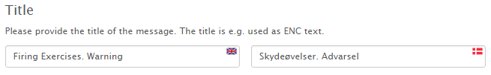

Description

The localizable “Description” fields are used for a detailed message description. The descriptions are composed in rich-text editors:

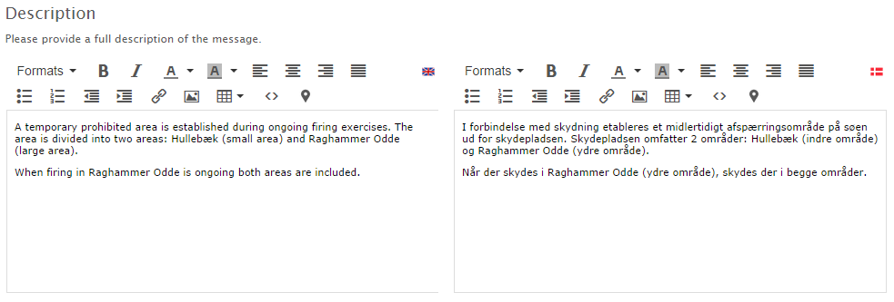

The rich-text editors allow for fairly advanced typography, and elements such as tables, links, images, etc.

Links and images are particularly useful in conjunction with message attachments (see next section), whereby you can insert attached images directly into the message description, or provide a direct link to, say, an attached chart update PDF. See left example below:

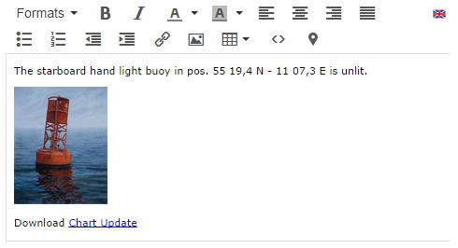 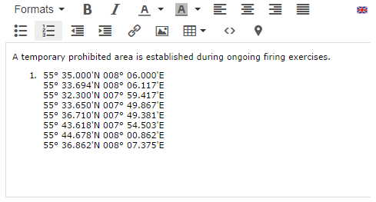

An MSI-NM specific text editor tool, “Insert Location” (), has been included as a proof-of-concept tool. It will insert the properly formatted locations of the message into the description field. See right example above.

A future text editor tool will allow for easy insertion of pictograms for buoys, chart symbols, etc.

Attachments

Messages can be associated with a list of file attachments. The attached files could e.g. be relevant images or chart update PDF files.

Attached files can be downloaded by users from the Message Details dialog, or they can be embedded or linked to directly in the message description, as described in the previous section.

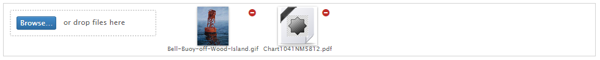

You can either click the “Browse…” button to select the files to attach, or drag the files onto the Browse button. On mobile devices, clicking “Browse…” will give you access to take a photo or select existing files.

Click the red minus-button next to the thumbnail, to delete the attachment.

Currently, there is an important limitation regarding attachments: When you upload or delete an attachment, it takes effect immediately – not when the message is saved.

Miscellaneous

The message contains an optional and localizable set of miscellaneous fields that can be filled out for the message: Note, Publication and Source.

In addition, the “Original Information” flag can be set if the message is based on original information.

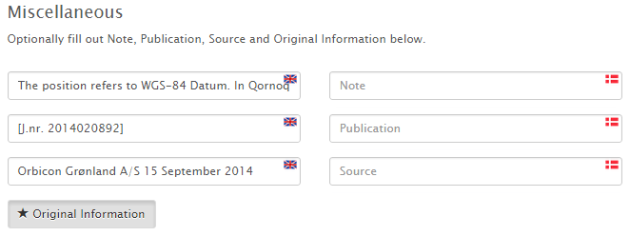

Publications

The MSI-NM system contains a pluggable publication system, which allows messages to be promulgated via various external channels. The Publisher plug-ins must be enabled by a system administrator on the Publishers Admin Page detailed in a later section. Also, some publishers, such as Twitter, will require additional configuration by the system administrator to work properly.

Currently four publishers are available: Mail, NAVTEX, Twitter and Maritime Cloud. Each publisher may install a UI pane in the Message Editor Publications section.

**Publication via Mail**

The Mail Publication tab merely contains a flag to select whether or not to publish the message via mailing lists:

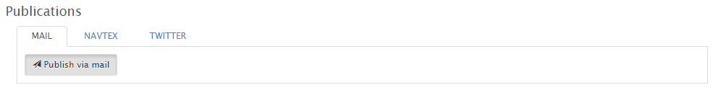

**Publication via NAVTEX**

The Navtex Publication tab contains a flag to select whether or not to publish the message via NAVTEX, which is actually a transmitter-specific NAVTEX mailing list.

The tab also contains options to select the transmitter and priority of the message, plus the actual NAVTEX message.

The “Generate” button will attempt to generate a NAVTEX message that adheres to the NAVTEX guidelines based on the message data. However, the generated message should be manually corrected afterwards.

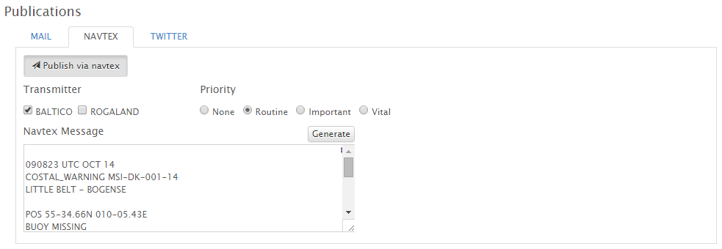

**Publication via Twitter**

The Twitter Publication tab contains a flag to select whether or not to publish the message via Twitter. If selected, a tweet will be submitted when the message is published.

The tab also contains a field for the actual tweet (max 140 chars), and a “Generate” button that will generate a proposed tweet text based on the message data.

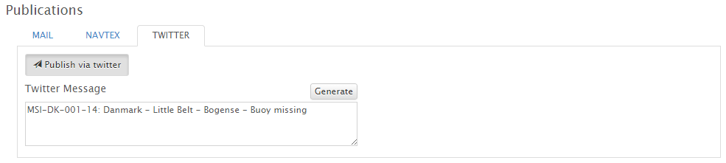

A sample tweet generated by MSI-NM:

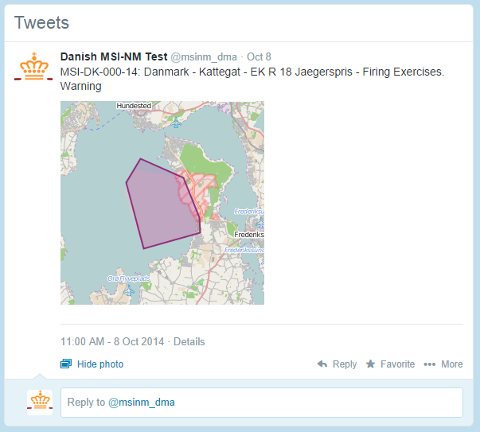

**Publication via Maritime Cloud**

The Maritime Cloud publisher does not install a publication tab in the Message Editor. If the Maritime Cloud publisher is enabled, messages will always be broadcast via the cloud when the messages are published.

**Publication via Audio**

The Audio Publication tab contains a flag to select whether or not to publish the message via Audio, that is, to be read up and broadcast via the radio in the local language.

Since the person reading the message aloud is likely not a mariner, the purpose of the Audio version is to spell out all the terms and abbreviations used in the standard message description.

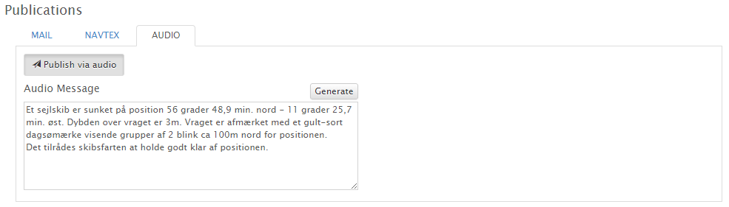

## Message Management

Whereas the Message Editor, detailed in the previous section, is used for writing and editing messages, the Message Management Page is used for controlling the life-cycle of a message. The page provides functions for publishing or deleting a draft message, cancelling a published message, etc.

You enter the Management Page of a message by choosing the “Manage…” option of the message details menu, only visible for editors and administrators.

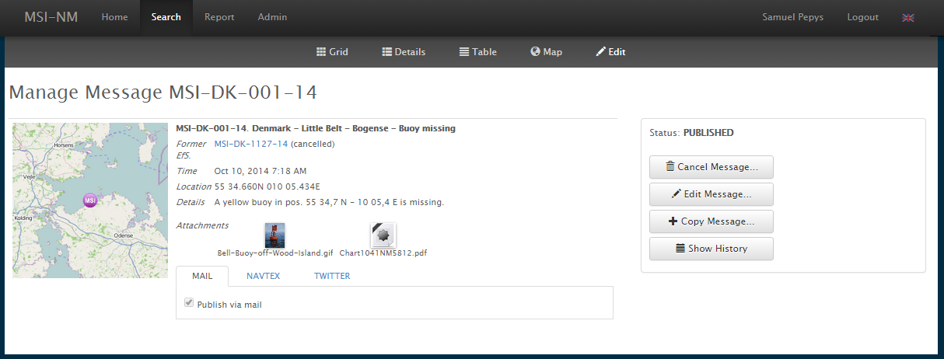

The Management Page provides a detailed read-only view of the message, plus a panel with buttons for controlling the life-cycle of the message.

The available actions depends on the status of the message:

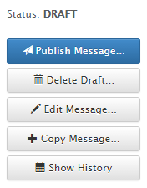 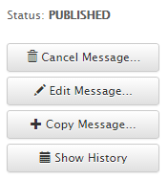 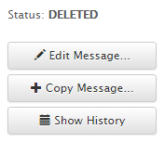 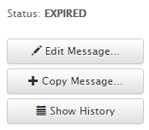 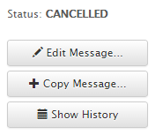

The actions are detailed below one by one.

Publish Message

The “Publish Message” action is available solely for draft messages. Upon confirmation, the message will change status to “published”, and appear in the list of active messages on the MSI-NM website.

Additionally, the configured publishers will be triggered, so that a published message may result in mailing list e-mails being sent out, Twitter tweets being submitted, Maritime Cloud clients being updated, etc.

Delete Draft

The “Delete Draft” action is only available for draft messages. The “deleted” status serves as an end-of-life status for draft messages that should never be published.

Cancel Message

Once a message has been published, there are two ways the message can exit the “published” status. If the message has a valid-to date, and this date has passed, then the MSI-NM system will automatically expire the message, leaving the message in an “expired” status.

Alternatively, an editor or administrator can manually cancel the message using the “Cancel Message” action on the Management Page.

Upon cancelling a message, you get the option to create a cancellation message:

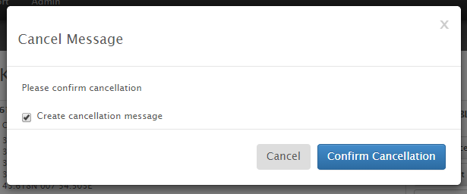

If this option is left checked, the message will be cancelled and you will be routed to the Message Editor page which will contain a new, unsaved draft message that is essentially a copy of the cancelled message. The draft message also contains a “Cancelled” reference to the original message. You can then edit the draft message, save it and publish it as per usual.

Edit Message

The “Edit Message” is merely a link that redirect you to the Edit Page for the message. For editors and administrators, only draft messages can be editor (system administrator can edit all messages).

Copy Message

The “Copy Message” action will route you to the Message Editor page which will contain a new unsaved draft message that is essentially a copy of the original message. The draft message also contains a “Reference” reference to the original message. You can then edit the draft message, save it and publish it as per usual.

Show History

The “Show History” button is actually a toggle button that switches history mode on and off.

Messages are versioned, and a new revision is created every time you edit the message or update its life-cycle status.

The History panel lists all the revisions of a message, including the date of the revision and the user who made the change:

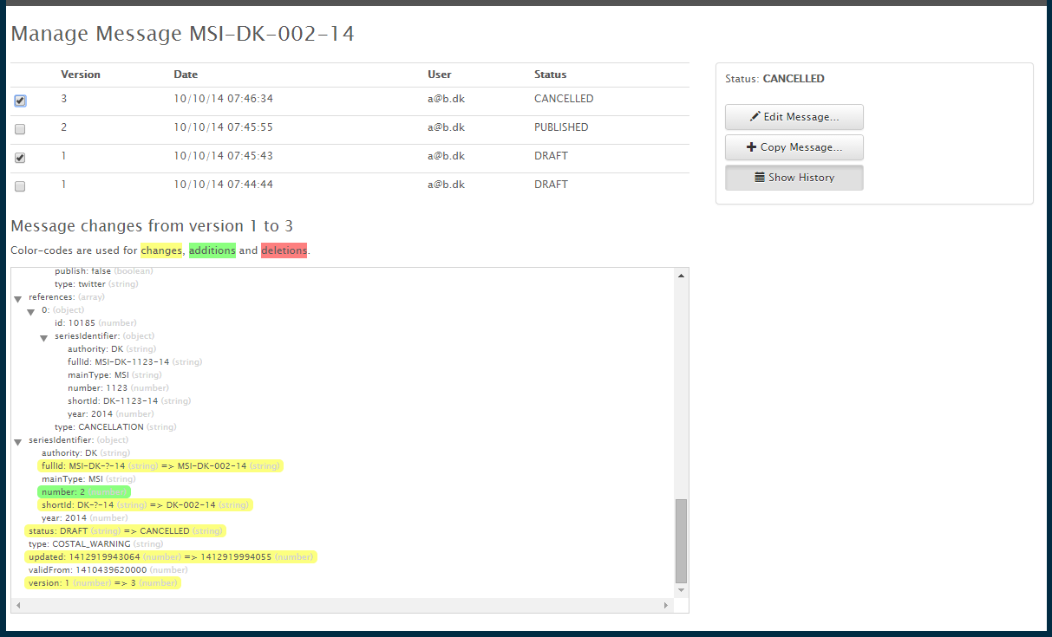

When you check the checkbox next to a single revision, you get to see the associated message data for that particular revision.

If you check-select two revisions, you will see a comparison of the two selected revisions with color-coding to indicate changed fields, additions and deleted fields.

The History panel should be considered an expert function, as the format of the data displayed for the revisions is rather technical.

## Admin Pages

The Admin Pages are available to administrators and system administrators, and cover pages used to manage users, mailing lists, charts, areas, categories and publishers:

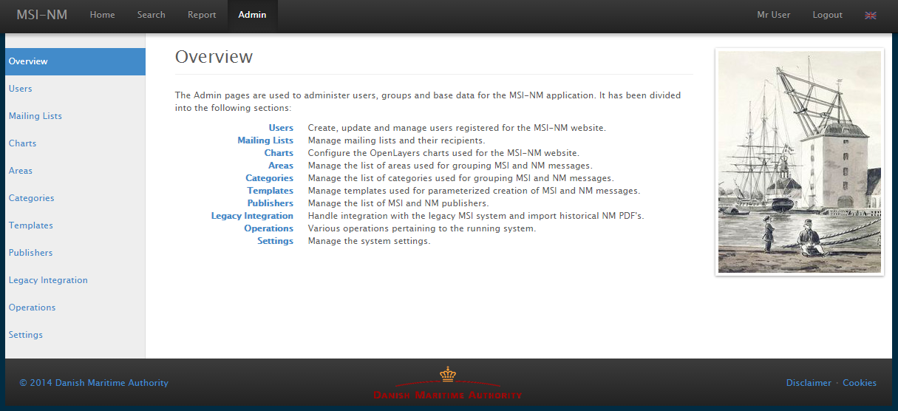

System administrators gets access to a couple of extra pages for managing legacy integration, operations, and the underlying system settings.

Legacy integration requires the presence of a system-specific legacy module (such as a module that provides legacy integration with Danish legacy MSI and NM systems), and is thus not detailed in this manual.

### Users Admin Page

The Users Admin Page lists all registered users. As an administrator, you can add new users or edit existing users:

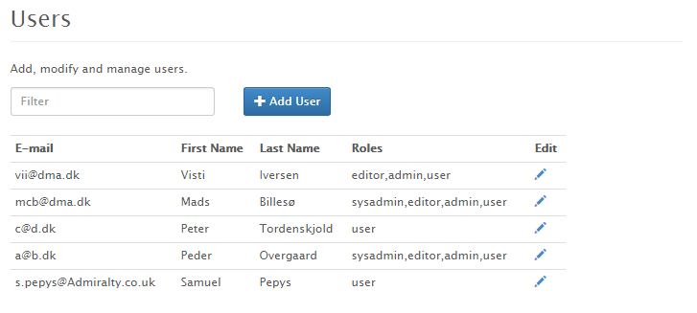

The dialogs for creating new users and editing existing users are almost identical:

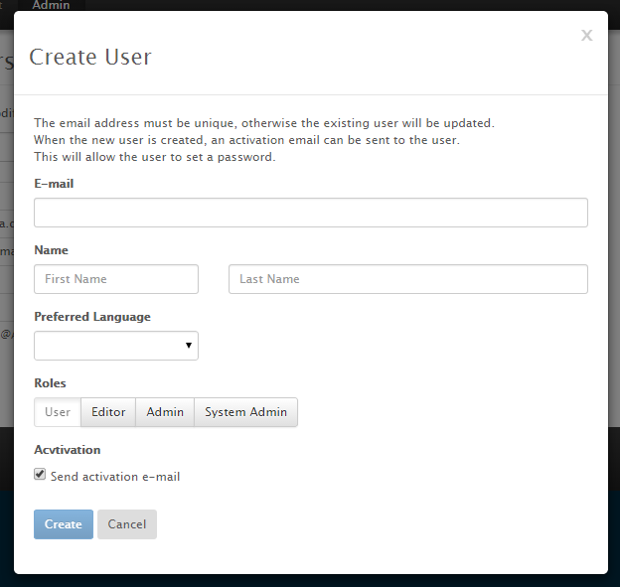

The one exception is that when creating a new user, you get an extra option to send an activation e-mail to the user.

Normally, the only case where you would not want an activation e-mail to be sent, is if you create a recipient for a mailing list who never needs to log in at the MSI-NM website.

When you assign roles to a user, please respect the hierarchical nature of the roles. So, if you assign the “Admin” role, please also assign the “Editor” role (the “User” role is mandatory), and so forth.

### Mailing Lists Admin Page

As described in previous sections, mailing lists are created from the Search Menu on the Search Page, and users can manage their own subscription from the Users Menu available in the Top Menu.

The Mailing Lists Admin Page lists all mailing lists along with their type, filters and recipients.

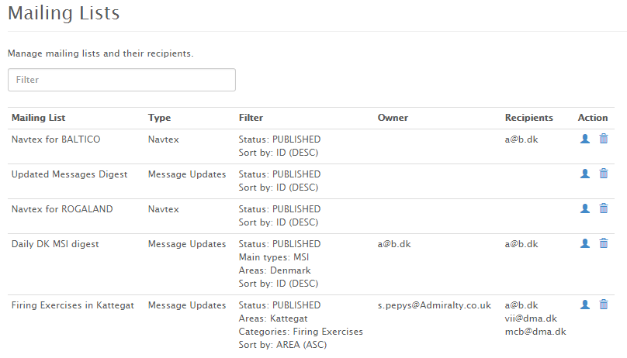

As an administrator you can delete mailing lists and manage the list of subscribers using the action icons next to the mailing lists.

So, for example, when the NAVTEX publisher is enabled, there will automatically be created a mailing list of type Navtex for each of the transmitters configured (Baltico and Rogaland in the example above). Your task as an administrator will be to add recipients to these mailing lists, by first creating a valid user (see previous section), and the adding the user as a recipient to the mailing list on the Mailing Lists Admin Page:

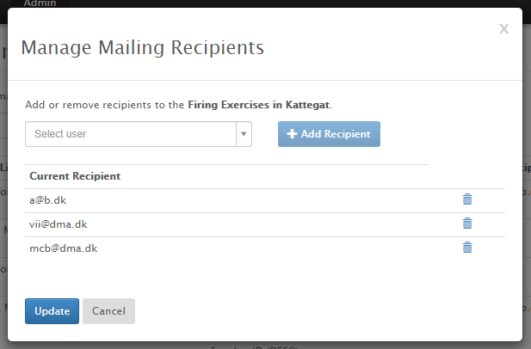

### Charts Admin Page

Messages can be associated with a list of sea charts in the Message Editor, and message search results can be filtered by charts.

The charts are managed on the Charts Admin Page, where the administrator can add, edit and delete charts.

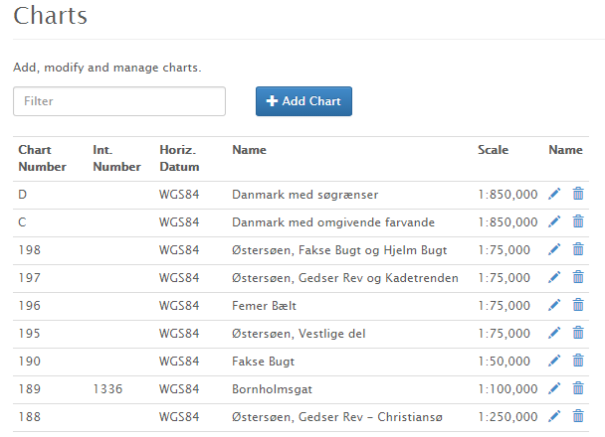

The charts are mainly defined by their regional chart number and international number. However, you may also specify the scale and geographical extent of the charts:

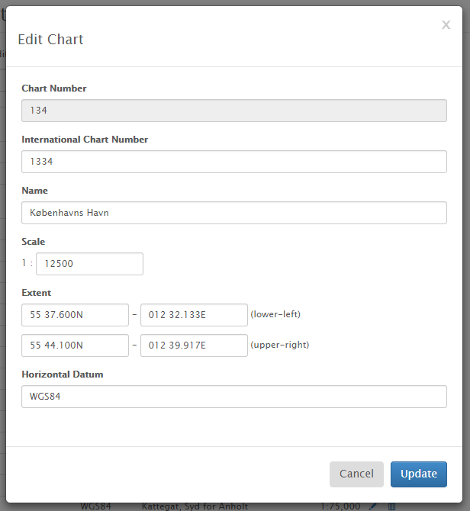

If these fields are filled out, then it becomes very easy to determine which charts should be assigned to message in the Message Editor, since this can be computed from the geographical locations specified for the message. Furthermore, the charts can be sorted with the highest resolution chart taking precedence.

### Areas Admin Page

Messages must be associated with an area in the Message Editor, and message search results can be filtered by areas.

The areas are managed on the Areas Admin Page, where the administrator can add, edit and delete areas.

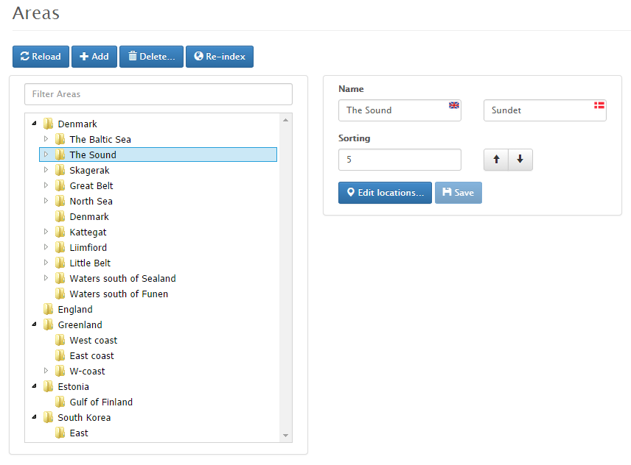

The area tree can be arbitrarily nested, and the ordering of the areas with the same parent area will affect the area sorting on the Search page.

An existing area is edited by selecting it in the area tree, and then edit the details in the right-hand editor.

A new area is added by first selecting the parent area, and then clicking the “Add” button, whereby a blank unsaved template area will be created under the selected parent.

In the area editor you fill out the localizable name of the area, a sort key, and optionally define the geographical locations associated with the area.

The “Edit Locations” button will open the Location Editor detailed in a previous section. If the locations have been defined for an area, you can subsequently easily copy these to a message in the Message Editor - a useful feature for, say, firing exercises, where the area is well-defined.

The sorting key is uses to sort areas with the same parent area, i.e. sibling areas. You can use drag-and-drop to move areas from one parent area to another parent area.

When you have changed the sort order or structure of the area tree, it may take a few minutes for the changes to take effect. You can click “Re-index” for the changes to take effect immediately.

### Categories Admin Page

Messages can be associated with a list of categories in the Message Editor, and message search results can be filtered by categories.

Furthermore, the templates used for automatically creating standard messages are tied to the message category selection.

The categories are managed on the Categories Admin Page, where the administrator can add, edit and delete categories.

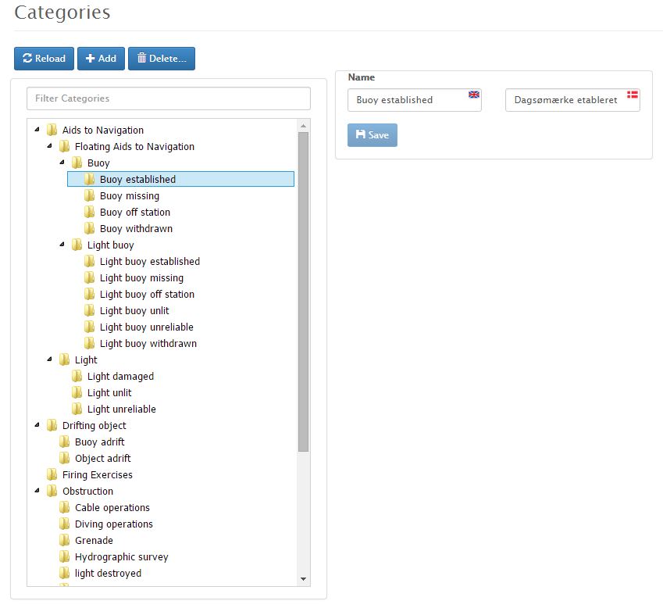

An existing category is edited by selecting it in the category tree, and then edit the details in the right-hand editor.

A new category is added by first selecting the parent category, and then clicking the “Add” button, whereby a blank unsaved template category will be created under the selected parent.

In the category editor you fill out the localizable name of the category.

The category tree can be arbitrarily nested and you can use drag-and-drop to move categories from one parent category to another parent category.

### Templates Admin Page

Templates can be executed from within the message editor page as described in the Message Editor section.

Defining and maintaining the templates on the Templates Admin Page is a rather complex task that should be performed by IT savvy personnel. The underlying technology used for templates is Freemarker (see http://freemarker.org), and the maintainer of the MSI-NM templates should be acquainted with Freemarker in order to manage anything more than trivial templates.

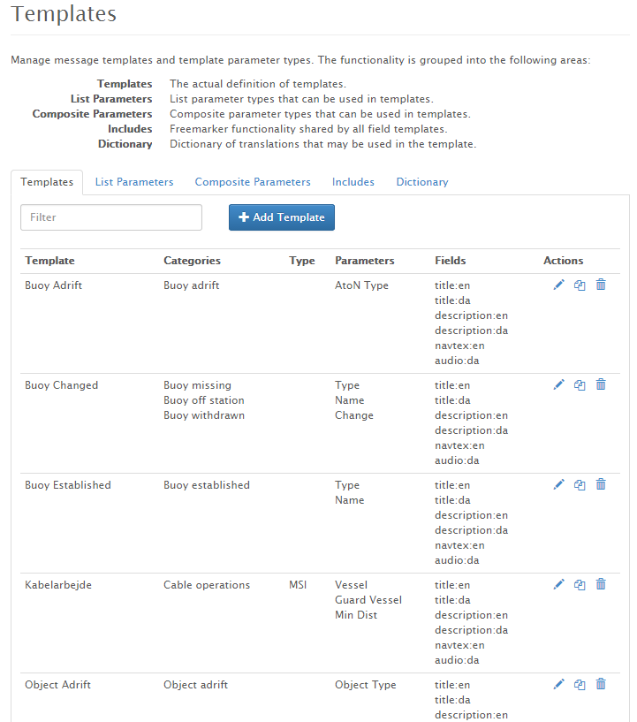

The Templates Admin page is sub-divided into five tabs for the template list, the list parameter type definitions, the composite parameter type definitions, the Freemarker include files, and a template dictionary respectively, all of which are detailed below.

Templates Tab

On the Templates tab, you may add, copy, edit or delete individual templates. The template editor dialog can be seen below:

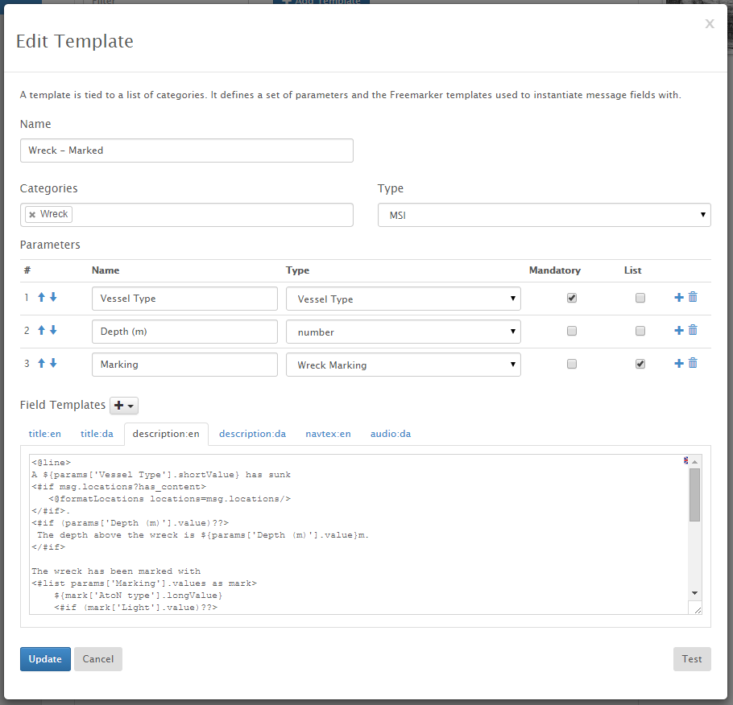

The corresponding template execution dialog, as executed from the Message Editor page:



In the template editor dialog, you can edit the following fields:

* Name: A unique name identifying the template.
* Categories: The template will be made available to a message in the Message Editor when the message is assigned one of the template categories, or any sub-category of the template categories.
* Type: If either the MSI or NM type is selected, then the template will only be made available to messages of that kind in the Message Editor.
* Parameters: Defines the list of parameters that the user can fill out upon executing the template in the message editor. A template parameter must have a unique (within the template) name and a type. The type is either a *base type* (“text”, “number” or “Boolean”), one of the *list parameter types* defined on the “List Parameters” tab or one of the *composite parameter types* defined on the “Composite Parameters” tab.  
  Additionally, you define if the parameter is mandatory, and whether or the user can fill out a single value or a list of values for the given parameter.
* Field Templates: Defines a Freemarker field template for each message field that should be populated when the template is executed. The list of available fields consists of “title” and “description” in all supported languages, plus the fields defined by enabled publishers, such as an English NAVTEX field or a native language Audio field.

The Freemarker field templates can access the current message of the Message Editor via the “msg” reference, and the parameter values via the “params” reference.

This manual is not a Freemarker manual, but the following table will give a few Freemarker snippets to help along:

|  |  |
| --- | --- |
| Freemaker Snippet | Explanation |
| <@formatTitle msg=msg /> | Formats a title for the current message, “msg”, by calling the “formatTitle” Freemarker macro. |
| <#macro formatTitle msg>  <#list msg.categories as cat>  ${cat.descs[0].name}  <#if cat_has_next>. </#if>  </#list>  </#macro> | The definition of the “formatTitle” Freemarker macro, which iterates over all categories of a message and prints the name of the categories. |
| ${params['Type'].longValue?cap_first}  <#if (params['Name'].value)??>  ${params['Name'].value}  </#if>  has been established | First prints out a buoy type defined by the “Type” template parameter. List parameter types have a shortValue and a longValue (such as “red buoy” and “a red buoy” respectively). Also capitalizes the first letter of the buoy type. Next, prints out the buoy name defined by the optional “Name” template parameter. |
| The wreck has been marked with  <#list params['Marking'].values as mark>  ${mark['AtoN type'].longValue}  <#if (mark['Light'].value)??>  showing ${lightFormatter.format(mark['Light'].value)}  </#if>  <#if mark_has_next>, and </#if>  </#list>. | Iterates over a list of “Marking” parameter values. The “Marking” parameter is a composite parameter type which in turn is composed of an “AtoN type” parameter and an optional “Light” parameter.  The “lightFormatter” helper class is used to format a light characteristic value as a human readable text. |

List Parameters Tab

On the “List Parameters” tab, you may add, edit and delete *list parameter types*. A list parameter type can be used as the type of a template parameter.

Each List Parameter Type defines a set of possible values to select from, where each value is translated to all supported languages of the MSI-NM system. Furthermore, each value may take two forms, a short value form and a long value form, as exemplified below:

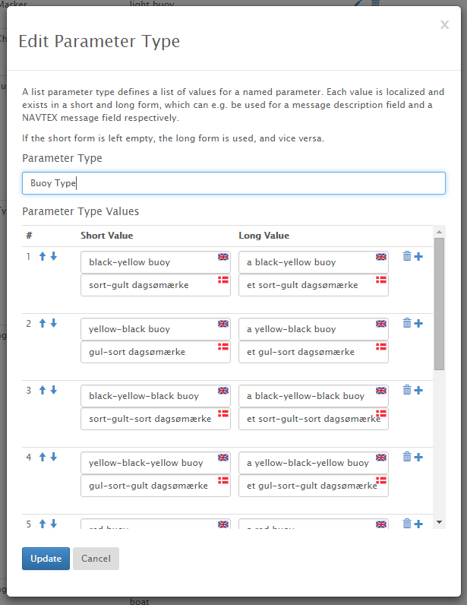

The short value form is typically used in e.g. title field templates or NAVTEX field templates, whereas the long value form is likely to be used in description field templates.

Composite Parameters Tab

On the “Composite Parameters” tab, you may add, edit and delete *composite parameter types*. A composite parameter type can be used as the type of a template parameter.

Each Composite Parameter Type is defined as a list of other parameters, as exemplified below:

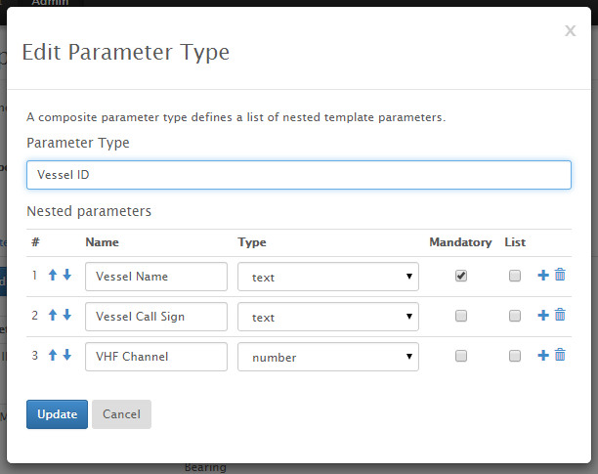

Includes Tab

On the “Includes” tab, you may add, edit and delete *Freemarker Include Files*. A Freemarker include file is simply a Freemarker template that automatically gets included in all field templates. This allows you to e.g. define a set of common Freemarker macros and variables that can be called directly from the field templates.

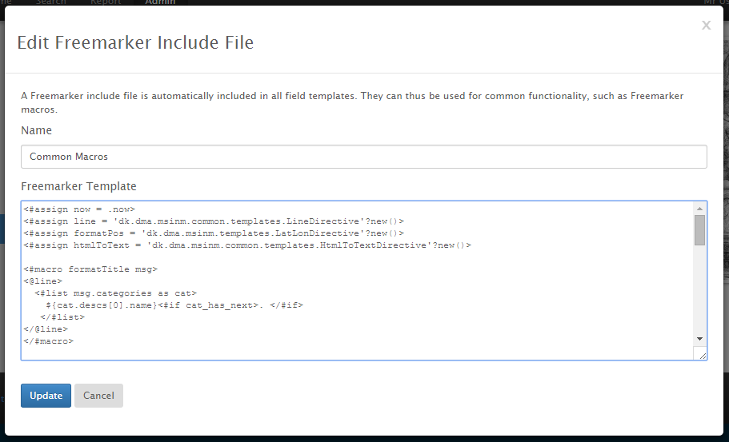

Dictionary Tab

On the “Dictionary” tab, you may add, edit and deletedictionary terms that can be used in the Freemarker templates.

Each dictionary term has an identifying key and a translation for each supported language:

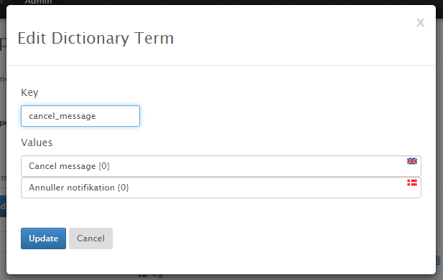

The dictionary is particularly useful in the Freemarker Includes, since this allow the include files to be generic and not tied to a specific language.

The “cancel_message” term defined above, can be used in a Freemarker template calling the “text” function. Example:

* ${text('cancel_message',msg.seriesIdentifier.fullId)}.

### Publishers Admin Page

Publishers have already been described in the Message Editor section, and are used to promulgate messages via different channels, such as mailing lists, NAVTEX, Twitter and the Maritime Cloud.

Before these publishers can be associated with a message, they must be enabled globally by an administrator on the Publishers Admin Page:

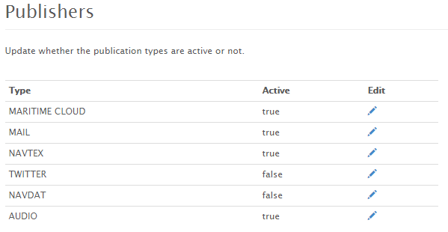

If a publisher is disabled again, publishing will stop immediately, irrespective of whether a message has already been configured to use the publisher or not.

### Operations Admin Page

The Operations Admin Page is only available to system administrators. At the time of writing it merely contains a few actions for flushing caches and re-building search indexes.

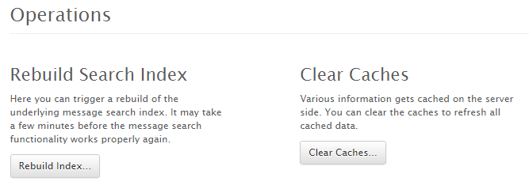

### Settings Admin Page

The Settings Admin Page is only available to system administrators. It lists the system variables used by the underlying MSI-NM system.

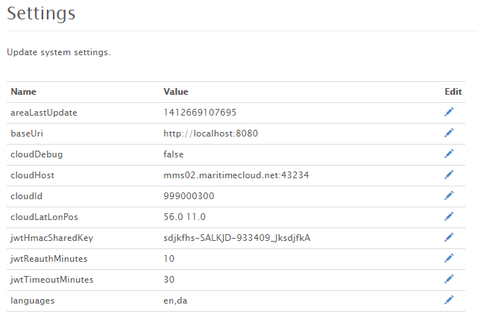

The system administrator can modify the values of the settings, however, since some of the system variables are cached, it may require a restart for the changes to take effect.

## Report Page

The Report Page can be used by all logged in users to report an observation relevant to the maritime authorities:

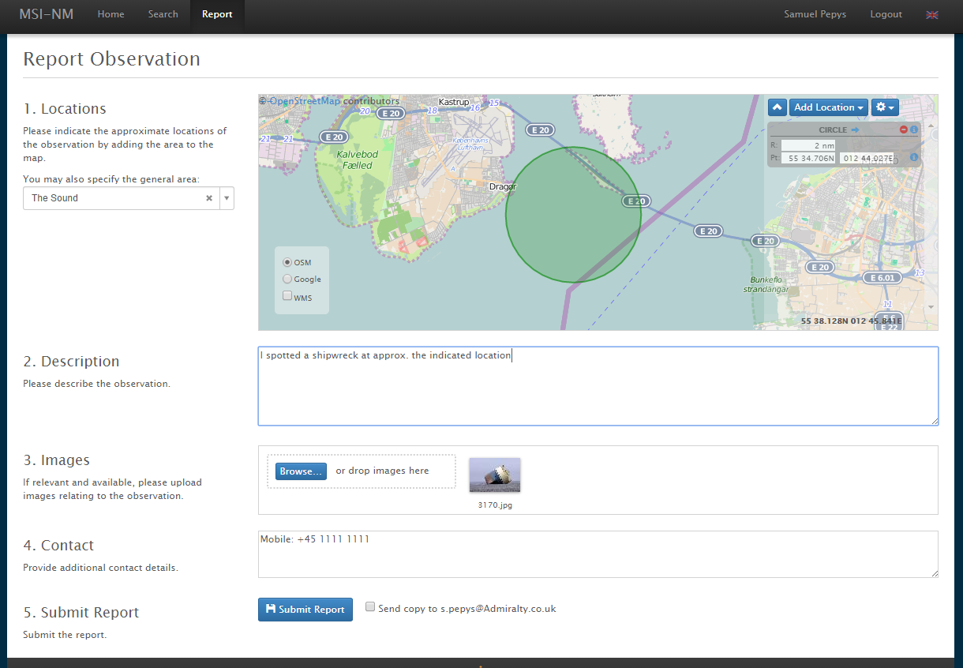

The user is asked to provide details about the observation such as the location, a description and contact details. Additionally, the user can upload images or other files relevant to the report – or even use her smartphone to snap a photo.

Pending Reports

When the user has reported an observation, an e-mail is sent to a pre-configured e-mail address, i.e. the duty officer at the maritime authority.

Furthermore, if an editor or administrator enters the Report Page, they will see the list of pending reports, and can discard the reports or create an NM or MSI message based on the reports (not implemented yet):

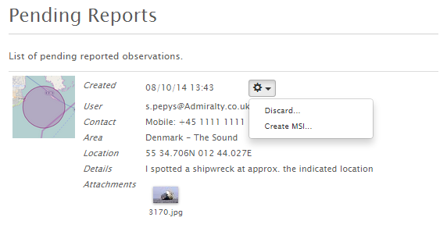

*A pending report*

# EPD Integration

This user manual is not an EPD user manual, and so, this section will only detail where the MSI-NM EPD integration differs from the usual EPD MSI functionality.

The main EPD chart, with the MSI-NM layer turned on, looks much like the previous versions, except you get NM symbols as well as MSI symbols:

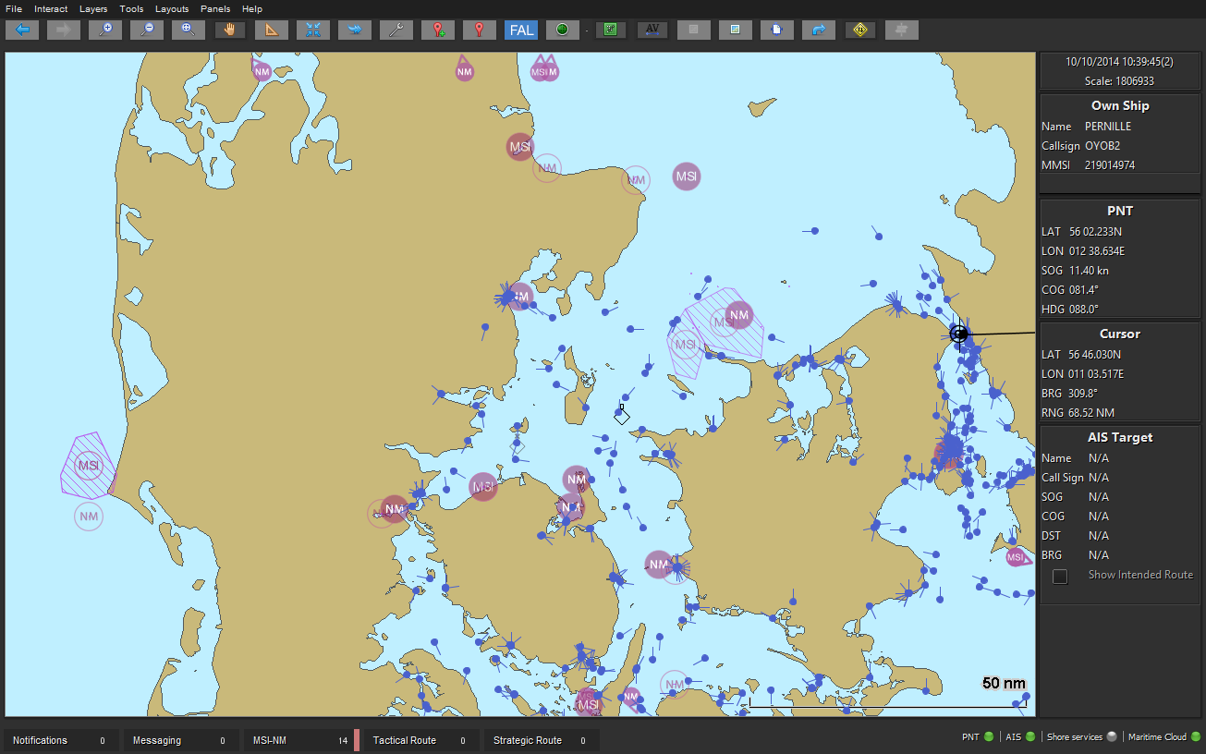

The old MSI Notification Center panel has been replaced with a new MSI-NM panel, which displays the active MSI and NM messages:

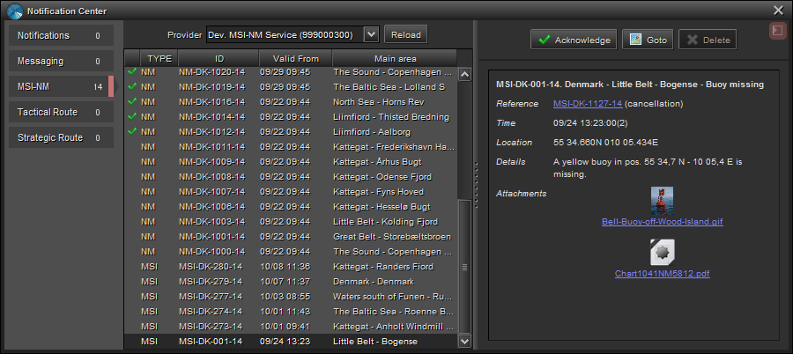

The MSI-NM details panel now displays a message similarly to the way message details are displayed of the MSI-NM website.

Above the MSI-NM message list, you will find a new Provider selector, which displays all the MSI-NM service provides available via the Maritime Cloud:

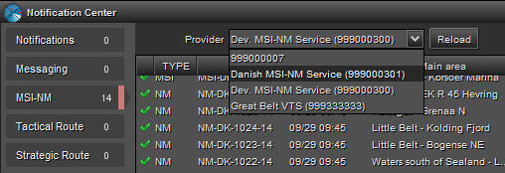

Click “Reload” after selecting a new provider, to refresh the list of MSI-NM messages.